Neighborhood Rescue of America  
Proposal for Fundraising

Stewart Huston Charitable Trust - Secular Program

|  |  |
| --- | --- |
|  | The purpose of the Trust is to provide funds, technical assistance and collaboration on behalf of non-profit organizations engaged exclusively in religious, charitable or educational work; to extend opportunities to deserving needy persons and, in general, to promote any of the above causes.  The Trustees promote the opportunity for philanthropic impact with the Trust’s giving — while not totally excluding other locations — in two geographic areas which had strong relevance to Stewart Huston’s life: Chester County, Pennsylvania, and Savannah, Georgia.  Stewart Huston Charitable Trust supports evangelical activities in Savannah, GA and Coatesville, PA areas, and secular charitable activities around Coatesville. |

# Overview

|  |  |
| --- | --- |
|  | The Stewart Huston Charitable Trust continues to foster a culture of conservative investing not only in the money markets but also in the organizations we support. The Stewart Huston Charitable Trust is committed to our communities and assisting organizations who serve our neighbors. |

In 2017, $556,500 was distributed in 39 different grants and a matching gift. These grants were all to charitable organizations qualifying under the Section 509 of the Internal Revenue Service Code 501(c)(3), including but not limited to, health, civic, historic preservation, community renewal as well as Protestant Trinitarian/Evangelical religious groups.

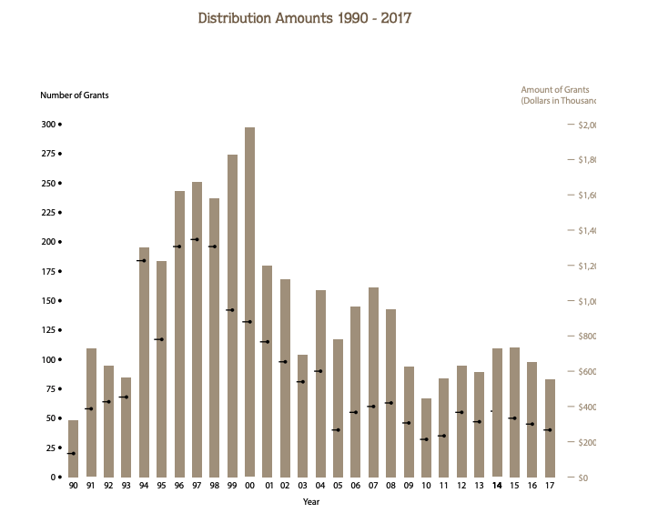

## General Organizational Requirements

|  |  |
| --- | --- |
|  | The following requirements are mandatory for all organizations requesting funds from The Stewart Huston Charitable Trust: |

* **Tax Status**

Applicants must have evidence of being granted 501© (3) tax exemption status by the Internal Revenue Service.Need #2: improve upon weaknesses in upsell/cross-sell volumes

* **Types of Support**

While the Trustees prefer to provide support for specific projects that address a particular community need or issue, support is considered for general operations, capital projects, equipment purchases, and last-resort funding on a selective case-by-case and meritorious basis.

* **Demonstrated Need**

Requests for support must demonstrate that the program/organization is addressing a known community need, and not simply duplicating existing efforts.

## General Grant Restrictions

|  |  |
| --- | --- |
|  | The following restrictions apply to all organizations requesting funds from The Stewart Huston Charitable Trust: |

* All grant awards are subject to the vote of the full Trustee body.
* It is not the intention of the Trustees to establish a permanent grant relationship with grantees.
* During the period in which a present grantee is receiving tentative payments on a previously awarded grant, the Trustees will not entertain a new grant request until the multi-year commitment is completed.
* Additionally, for good and sufficient reasons, the Trustees reserve the right to cancel future grant payments on any multi-year commitments they have made.
* The Trustees will not award a new grant to an organization which has unfulfilled reporting requirements from a previous grant award.

|  |  |
| --- | --- |
|  | With regard to types of grants, the Trustees do not make grant awards for: |

* Financial support for individuals
* Endowment purposes
* Purchases of tickets for benefit purposes
* Coverage of continuing operating deficits

|  |  |
| --- | --- |
|  | Concerning types of organizations, support is not provided to the following: |

* Organizations not qualified for tax-exempt status under Section 501(c) (3) of the IRS code.
* Intermediate or pass-through organizations (other than United Way and Chester County Community Foundation) which in turn allocate funds to beneficiaries of their own selection.
* Groups such as fraternal organizations, political parties or candidates, veterans, labor or local civic groups, volunteer fire companies, and groups involved in influencing legislation. Companies, and groups involved in influencing legislation.

## Trinitarian Evangelical Distribution Guidelines

|  |  |
| --- | --- |
|  | Sixty percent of the annual distributions from the Trust are to be made for the benefit of Trinitarian Evangelical activities. Fifty percent of the annual distributions will be made for the benefit of Trinitarian Evangelical organizations in the Savannah, Georgia, area while ten percent of the annual distributions will be made for the benefit of Trinitarian Evangelical organizations in the Coatesville Pennsylvania, and other areas.  The Chester County Court has decreed that the phrase “Trinitarian Evangelical activities”, as used in Mr. Huston’s will, includes activities carried on by Protestant churches (other than Unitarian churches) and affiliated or related organizations which follow the Christian Gospel, including dissemination of the Christian Gospel and exemplification of Christian principles through social welfare and other charitable endeavors.  The court further rules that dissemination of the Christian Gospel includes activities such as preaching and conducting services, offering religious instruction, and distributing religious literature. Exemplification of Christian principles includes activities such as providing food and shelter to the homeless, maintaining orphanages, operating hospices, and conducting drug and alcohol abuse prevention and rehabilitation programs. |

**The Trust has five categories for Trinitarian Evangelical grants:**

* Churches
* Education
* Missions
* Social Outreach
* YMCA's

# Grant Request Process

|  |  |
| --- | --- |
|  | Trinitarian Evangelical grants are awarded twice per calendar year. Trinitarian/Evangelical proposals are due in the Trust office **by March 1 or September 1.**  Organizations interested in submitting a grant request may view the distribution guidelines and submit a grant request **at www.stewarthuston.org** |

Mr. Huston stipulated that forty percent of the annual distributions from the Trust are to be used for secular charitable activities within one hundred miles of Coatesville, Pennsylvania. Grants generally are made in the following program categories.

**Health and Human Services**

* Activities which promote community-based health care.
* Programs which provide emotional and physical support to children, youth, adults, and senior citizens, as well as those which strengthen families and assist individuals with special needs.
* Programs which increase employment opportunities and provide a means for developing self-reliance, responsibility and productivity among individuals in need.

**Civic Affairs**

* Projects that enhance the quality of life in local communities and revitalize them.
* Programs which provide educational opportunities for individuals, including those with special needs.
* Programs which promote human relations and understanding among diverse populations
* Activities addressing the special needs of youth at risk for delinquency, school drop-out, abuse, neglect, and pregnancy.
* Activities that enable a broad spectrum of citizens to have access to artistic and cultural experiences which may otherwise be denied them.
* Programs which help preserve/exhibit historic, artistic and cultural treasures.
* On a very limited basis, fundraising efforts such as festivals, concerts and other events.

# Submation List

|  |  |
| --- | --- |
|  | What will be required in the application? |

Online applications will require you to submit a summary of the organization, a description of the project, and the following attachments in a pdf format:

* IRS tax-exempt letter Statement that there has been no change in purpose, character or method of operation since the Agency’s IRS tax ruling was issued
* Pennsylvania Charitable Organizations Registration Certificate (any organization that has over $25,000 in gross revenue, regardless of location, must register in Pennsylvania before soliciting funds) of written confirmation of exemption
* Current by-laws
* Current board of directors list (with professional affiliation)
* Most recent 990 form filed with the IRS
* Most recent independent financial audit
* List of public/private funding sources for your organization during the past fiscal year
* Current semi-annual or annual report
* Examples of published media reviews
* Strategic plan for your organization
* Organizational flow chart
* Overall operating budget for current fiscal year